STUDENT NAME: Nancy Sarange Mainga
ADMISSION NUMBER: BIT/2025/32683
SCHOOL: Computing and informatics
PROGRAMME:
ACADEMIC YEAR: 3RD
SEMESTER: 1
LECTURER: Michael Nyoro
PHONE NUMBER: 0112127599

WEEK 8
TOOLS USED
Expo Go
Metro Bundler
VS code
Node.js
Npm
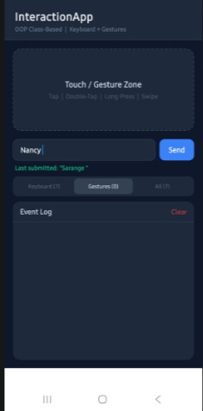

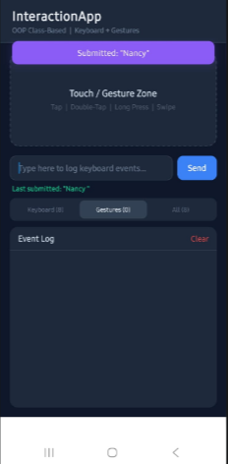

I developed a class based React Native app using Expo that detects keyboard input and touch gestures, and logs events in real time.
The application is structured across five classes following OOP principles.

